String theory

**Characters arrays and pointers**

In C/C++, char array are supposed to be null terminated

Char [10] =”Saajan”; //null termination implicit

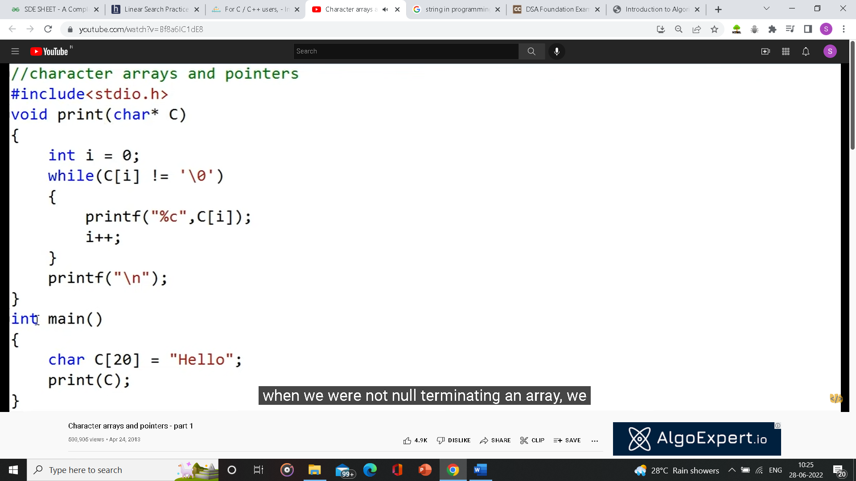

C[i] = *(C+i);

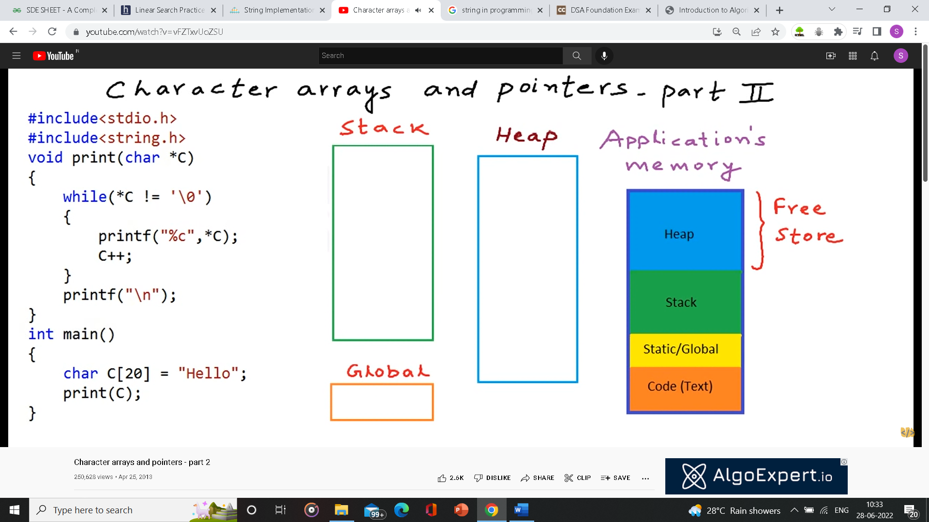

**C++ functions**

<https://www.scaler.com/topics/cpp/strings-in-cpp/#c---string-functions>

<https://www.scaler.com/topics/cpp/strings-in-cpp/#operations-on-strings>

<https://www.geeksforgeeks.org/c-string-class-and-its-applications/>

**Java functions**

<https://www.javatpoint.com/java-string>

In C++ string, if we try to access an index which is out of bound then it doesn’t return null pointer.

If we use string[index_outof_bound] in an array in an if condition, it returns false;

For eg: if(s[s.length()]) //false;